# Tidd bits of advice for the field! Pocket sized sewing repair, Coolers keeping cool, and Rain Proof minis.

Stanley Guinn

[Stanley Guinn](https://medium.com/@intrepid2008?source=post_page-----702a7ea4f338----------------------)

[Aug 17](https://medium.com/@intrepid2008/tidd-bits-of-advice-for-the-field-702a7ea4f338?source=post_page-----702a7ea4f338----------------------) · 3 min read

Image for post

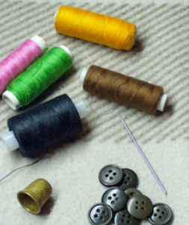

Have you ever been in the field and needed to repair a button or a small tear in your cloths or tent? One of the lightest, cheapest, and easiest sewing repair kit ideas I have ever seen is simply using a cardboard match book. Remove all of the matches from the book, then cut slits along the outer edge of the matchbook. You can wrap different kind of thread inside those slits for later use or fishing line for a survival kit. Next cut a small piece of scrap cloth and glue it flat to the inside of the top flap. This is wear you can stick bobby pins and needles. You can also use a few paperclips over the thread on the matchbook to not only hold the thread in place but also have the paper clips to utilize for any purpose in a pinch. All in something that is smaller than a credit card and only weighs ounces.

Image for post

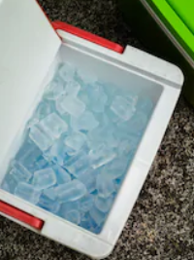

Every curious about how to keep your cooler cool and save some ice in camp while you are off for the day having your adventures? Sticking it in the shade isn't always the best idea when you will be gone all day considering that at some point it will probably still end up baking in the sun for some period. Grab an old white bed sheet and old white beach towel. First thing in the morning before the big adventure soak the old bed sheet and old beach towel in water then wrap the white sheet around the cooler placed in the shade with the old beach towel draped on top of the sheet to keep it from blowing off. During the course of the day the white linens will reflect the sunrays while also keeping the outside surface of the cooler cool as the water evaporates.

Image for post



Ever thought about one of the cheapest and easiest ways to keep small gear and electronics water proof on your next trip? Jumbo sized balloons that can be bought at most Dollar stores will do the trick. Anytime you are boating, canoeing, camping, backpacking, or riding on your motorcycle and may get caught in the rain this is one option that we can all get behind before having to replace that expensive cell phone or other gear. You can keep matches, sewing supplies, medical supplies, elect perfectly protected from moisture for just a couple dollars.